Microcystis botrys Teiling 1942

Phylum: Cyanobacteriophyta
Class: Cyanophyceae
Order: Chroococcales

Habitat: planktonic, pelagic
Distinctive features: A less abundant but common species of Microcystis in Lake Kinneret.
Organization: colonial
Color: green or brown
Cell shape: sphere
Colony shape: mostly spherical
Cell diameter (D): 3– 7 μm, median: 5.2 μm (N=1220)
Cell biovolume: 20 – 180 μm³, median: 75 μm³
Biovolume equation: Sphere, V = 4/3 π (D/2)³
Cells per colony: 30-5000; median: 200

Morphological features: Colonies are more or less spherical, with cells irregularly and densely aggregated in mucilaginous, spherical groups. The Mucilage around conlinies is wide, gelatinous, fine, colorless, sometimes indistinct, enveloping clusters of cells and extending distinctly beyond their margin, usually by more than 1 µm. Spherical cells with gas vacuoles, ~5 µm in diameter.
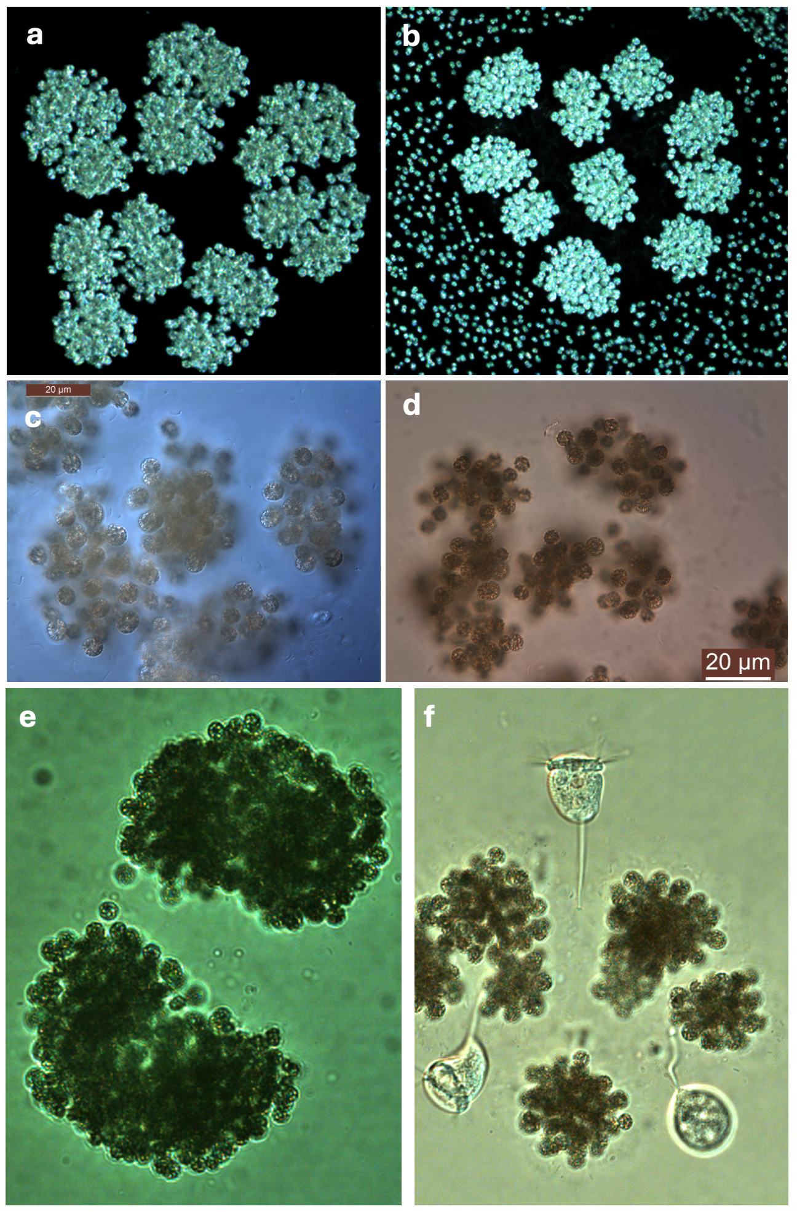
Plate 1. Various typical colonies of Microcystis botrys from Lake Kinneret, 2006-2021.(a, b) darkfield; (c-f) lightfield. (f) with 3 ciliates attached to a colony of M. botrys. Photos by Alla Alster,.
Ecology:
Microcystis botrys is common in Lake Kinneret (Fig. 1), but never dominant and never formed a major bloom. The species was recorded from 1974-1981, then not recorded at all until 2007 (Fig. 1). The species is more abundant from May to July, less abundant from August till February (Fig. 2a). Colony size shows a different annual pattern, with more cells per colony in winter-spring, less in summer (Fig. 2b). Cell volume varies only slightly such that after two full years of measurements a fixed volume per cell was applied for biomass calculations (not shown).
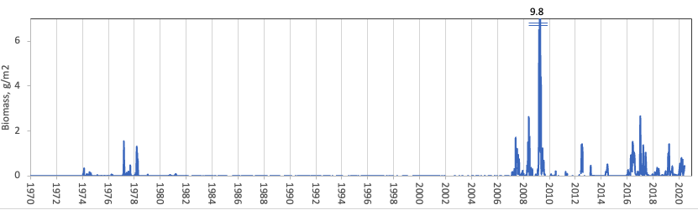
Figure 1. Time series of Microcystis botrys depth-integrated wet weight biomass (g m⁻²), Lake Kinneret, 1970-2020.
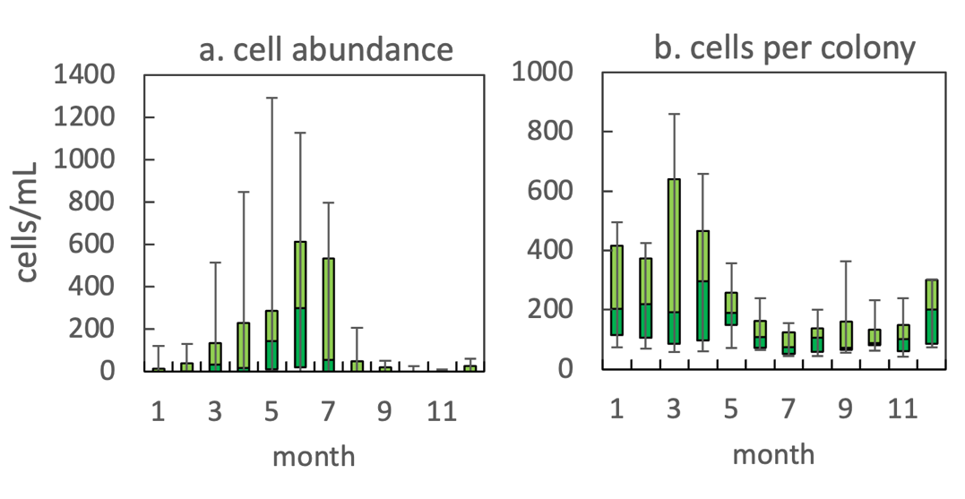
Figure 2. The annual pattern of Microcystis botrys parameters, based on data for 2007-2020: (a) water column cell abundance; (b) number of cells per colony. Statistics shown are: median – middle line; 25th to 75th percentiles – box content; 90th and 10th percentiles - top and bottom bars, respectively.
Physiological features: Like other species of Microcystis, M. wesenbergii is known to produce toxins. The toxicity of Kinneret M. wesenbergii was never tested because it doesn’t form blooms and we do not have a culture of it.

Environmental conditions:
M. botrys abundance was independent of water temperature, mixing depth, euphotic zone depth, alkalinity, calcium, nitrare and chloride concentrations.. All abundance peaks occurred at NH₄ < 30 µg L⁻¹.
Cite this record as:
Tamar Zohary, Alla Alster. [Date when Item was last updated]. Electronic publication. Israel Oceanographic & Limnological Research. [Date when last accessed].
Further reading:
Komárek J, Anagnostidis K. 1999. Cyanoprokaryota. 1. Chroococcales. In: Süßwasserflora von Mitteleuropa. Begründet von A. Pascher. Band 19/1. (Ettl H, Gärtner G, Heynig H, Mollenhauer D, Eds), pp. 1-548. Heidelberg & Berlin: Spektrum, Akademischer Verlag.
McGregor G, Fabbro LD, Lobegeiger JS. 2007. Freshwater planktic Chroococcales (Cyanoprokaryota) from North-Eastern Australia: a morphological evaluation. Nova Hedwigia 84(3/4): 299-331.

Genus species Authority Year
[Thumbnail photo here]

Phylum: Cyanobacteriophyta
Class: Cyanophyceae
Order: Chroococcales

Habitat: benthos, littoral
Distinctive features: colonial, forming masses in shallow waters
Organization: flagellated single cells
Color: yellow to golden-brown
Cell shape: mashroom-like, close to a sphere
Colony shape:
Cell diameter (D): 7.6 – 12.3 μm, median: 9.7 μm (N=587). Cell diameter varies significantly over an annual cycle, making it necessary to measure it routinely.
Cell length (L): ___
Cell biovolume: 230 – 1000 μm³, median: 470 μm³. Larger cell size in winter, smaller in summer (see Fig. 2b).
Biovolume equation: Sphere V, μm³ = 4/3 π (D/2)³. (or: regression eqn. based on >500 measurements of both D and L with V computed for a prolate sphaeroid).
Filament length:
Cells per filament:
Colony diameter:
Cells per colony:

Morphological features: text description
Plate 1. with 1 or more photos of the species, and descriptive text below each photo.Photo by Alla Alster.
Ecology: text description
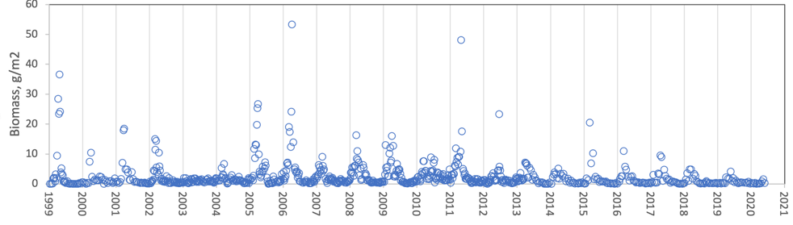
Figure 1. Time series of P. elpatiewskyi mean epilimnion cell abundance (cells mL⁻¹) [or: depth-integrated wet-weight biomass (g m⁻²), Lake Kinneret, 1999-2020.
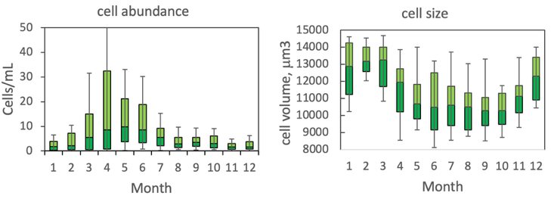
Figure 2. The annual pattern of water column cell abundance (left) and volume per cell (right) P. elpatiewskyi, based on data for 1978-2020. Statistics shown are: median – middle line; 25th to 75th percentiles – box content; 90th and 10th percentiles - top and bottom bars, respectively.

Fonts: 12 for numbers, 14 for axis labels. [Titles: a. cell abundance, b. cell size.] Bar colors: light green above median, strong green below media. Black borderline.
Physiological features:
Environmental conditions:
Figure 3. Gymnodinium abundance (cells mL⁻¹) vs. environmental parameters recorded at the site and time of sampling, showing tendency for higher cell concentrations at...
Cite this record as:
Tamar Zohary, Alla Alster. [Date when Item was last updated]. Electronic publication. Israel Oceanographic & Limnological Research. [Date when last accessed].
Further reading:

